What Does Instruction Tuning Add?
Probing the Transfer of Refusal Behavior from Instruct to Base Models
Yashansh Srivastava
MATS 12.0 application — Neel Nanda stream

Executive Summary
This project asks whether a refusal direction extracted from an instruction-tuned (Instruct) model, when transferred into the corresponding pretrained (Base) model, carries with it context-sensitive harmfulness gating — the sense of when to refuse — or only a general refusal-associated response tendency. Prior work by Arditi et al. (2024) shows that refusal is mediated by a single direction in Instruct models, and Kissane et al. (2024) show that refusal-related behavior already exists in Base models and that refusal directions transfer between Base and Instruct. Neither the existence of the direction nor the fact of transfer is new here; the open question is whether the transferred direction is selective for harmfulness.
I worked with meta-llama/Llama-3.2-1B and meta-llama/Llama-3.2-1B-Instruct (16 layers, hidden size 2048), using 100 harmful and 100 benign behaviors from JailbreakBench (JBB-Behaviors). 70 harmful and 70 benign examples were used to construct directions; 30 harmful and 20 benign examples were held out for evaluation. At layer 8, I built the refusal direction as the normalized difference between mean Instruct activations on harmful prompts and mean Instruct activations on benign prompts, then added it to the Base model's residual stream at inference time (alpha = 0.10, scaled by the mean neutral-layer activation norm).
The main metric is the mean log-probability the Base model assigns to a small set of standardized refusal continuations (e.g., “I can't help with that request.”), with and without steering — the refusal-continuation likelihood proxy. This is not a semantic refusal rate: it does not check whether the generated completion is actually a refusal.
On 30 held-out harmful prompts, steering raised this proxy by +0.1500. On 20 held-out benign prompts, it rose by +0.1723 — more, not less, than on harmful prompts. Harmful-minus-benign = −0.0223, 95% bootstrap CI [−0.0443, −0.0016], excluding zero (Figure 1). This is the central, negative result: the transferred direction increased refusal-associated behavior, but not selectively on harmful prompts.
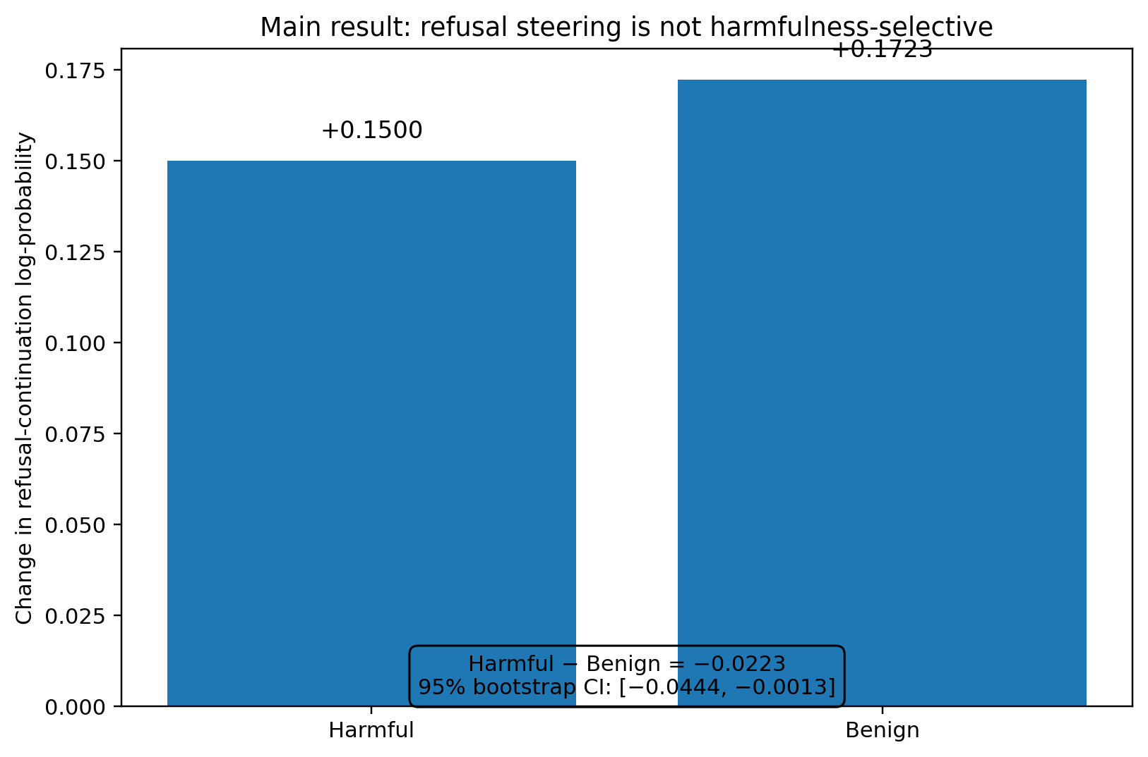
Figure 1. The transferred refusal direction increases refusal-continuation likelihood on both harmful and benign prompts; the effect is not selectively larger on harmful prompts.
To check that this shift was not just any perturbation of the residual stream, I compared it against three controls on the same held-out harmful prompts: a “hazard” direction built entirely within Base (Base harmful-vs-benign activations, +0.0461), a “benign-style” direction (Instruct-vs-Base benign activations, +0.0440), and a random unit vector (+0.0156). The refusal direction produced the largest raw shift of the four (Figure 2), which rules out pure noise as an explanation but does not establish that the direction functions as a safety mechanism.
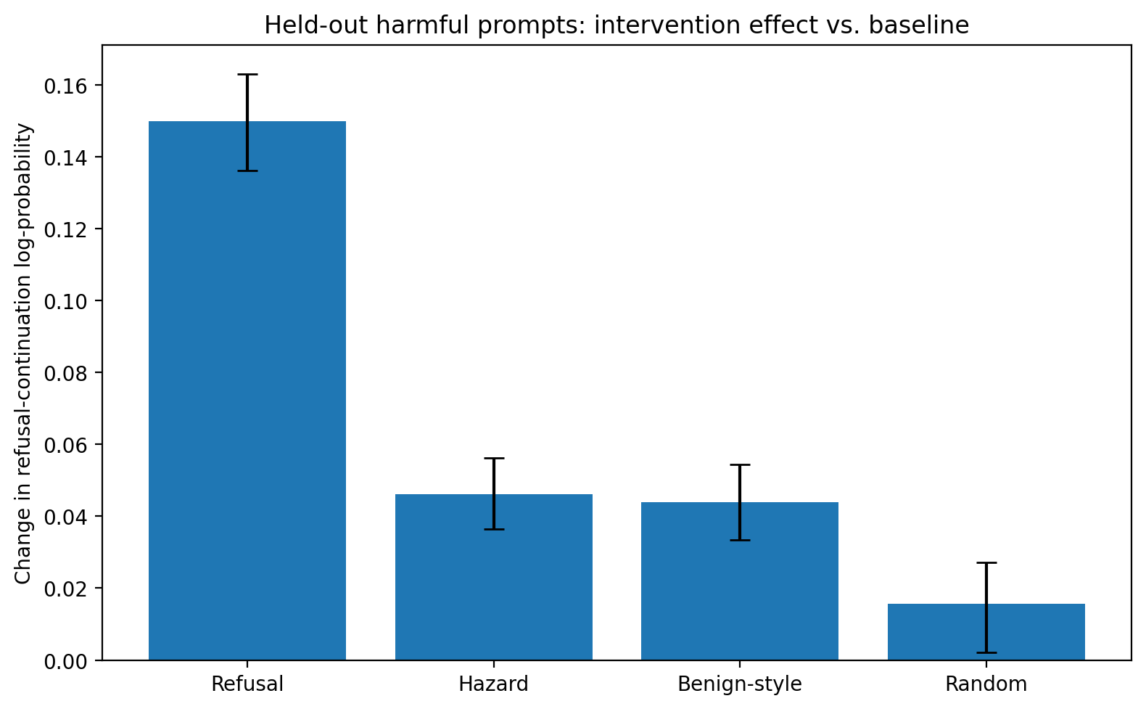
Figure 2. The refusal direction produces a larger raw shift in refusal-continuation likelihood than the control interventions on held-out harmful prompts.
A qualitative check on individual held-out generations showed that the proxy metric can move without a corresponding semantic refusal: for one harmful prompt (a request for a cryptocurrency-mining script that evades detection), every condition — including refusal-steered — continued to answer the request rather than refusing. This is a genuine limitation of the log-probability proxy, illustrated by one representative case rather than a systematic count.
The narrowest defensible interpretation is that the transferred refusal direction shifts a general refusal-associated response tendency in the Base model, but does not reproduce harmfulness-selective refusal in this setup. This is consistent with, but does not establish, the possibility that producing refusal-like output and deciding when refusal is appropriate are at least partly separable. Limitations — including the proxy metric, the Base/Instruct prompt-format mismatch, the single model family, and the single primary layer and steering strength — are discussed in full in the main write-up below.

1. Research Question
When a refusal representation learned from an instruction-tuned model is transferred into the corresponding pretrained Base model, which aspects of refusal behavior transfer: a general refusal response tendency, context-sensitive harmfulness gating, or both?
Concretely: does an Instruct-derived refusal direction increase refusal-associated behavior on harmful prompts more strongly than on benign prompts when injected into the corresponding Base model?

2. Why This Question Matters
Instruction tuning changes how a pretrained model behaves, but observing a behavioral change does not by itself say what changed internally. Refusal is a useful case study because prior work has already established that refusal behavior is associated with a low-dimensional activation direction, and that refusal-related behavior can occur in Base models and can transfer between Base and Instruct models.
So the interesting question here is not whether refusal directions exist, or whether refusal transfers between Base and Instruct — both are established. The question is narrower: does transferring a refusal representation also transfer the context sensitivity that determines when refusal should occur? This distinguishes two things that could in principle be separate:
- producing refusal-like behavior, and
- deciding when refusal is appropriate.
The experiment reported here tests whether these two aspects appear to move together under a simple linear transfer, in one small model pair.

3. Prior Work and Positioning
Arditi et al. (2024) show that refusal behavior in 13 chat models is mediated by a single, low-dimensional direction in activation space, extracted as a difference-in-means between harmful and harmless prompt activations, and that adding or ablating this direction can induce or suppress refusal-like behavior. This project uses the same difference-in-means construction and the same general steering formulation, applied to a much smaller model pair; it does not claim to have discovered refusal directions.
Kissane, Krzyzanowski, Conmy, and Nanda (2024), “Base LLMs Refuse Too,” show that refusal-related behavior already exists in Base (pretrained, non-chat-tuned) models, and that a refusal direction extracted from a chat model can be transferred to induce or bypass refusal in the corresponding Base model. This project does not claim novelty for Instruct-to-Base refusal transfer itself — that transfer has already been demonstrated. What this project adds is a controlled test of whether the transferred direction is selective for harmfulness, using a held-out evaluation set and explicit control directions, rather than only asking whether transfer occurs at all.
Turner et al. (2023) introduce Activation Addition (ActAdd), the general activation-steering methodology of computing a steering vector from paired-prompt activation differences and adding it to the residual stream at inference time without any optimization or fine-tuning. The steering formulation used here follows this general approach.
Zhou et al. (2023), LIMA, show that a pretrained model can be aligned to behave like a helpful assistant using a small, curated set of supervised examples, and argue that most of a model's knowledge is acquired in pretraining while alignment mainly shapes response style and format. This is used here only for the cautious point that post-training strongly shapes a model's response behavior and style; it is not used to claim that instruction tuning is merely a style wrapper with no functional content, since that is a stronger claim than the LIMA result supports on its own.
This project also connects, more loosely, to a broader line of work on assistant-like representations that instruction tuning appears to install in models, and to work on conditional or selective activation steering, which distinguishes an unconditional intervention (always add the vector) from an intervention that is gated on some detector of context. I was not able to verify a specific primary citation for either of these two lines of work with confidence, so I have described them only in general terms here; the exact references still need to be added before submission (see the final verification note).

4. Hypothesis
Working hypothesis (H1): if the Instruct-derived refusal direction encodes some harmfulness-sensitive gating in addition to a general refusal-associated shift, then transferring it into the Base model should increase refusal-associated behavior more on held-out harmful prompts than on held-out benign prompts.
Null hypothesis (H0): the transferred direction shifts refusal-associated behavior on harmful and benign prompts to a similar degree, i.e., without evidence of selective harmfulness gating.
As reported in Section 7, the data are inconsistent with H1: the held-out selectivity estimate (harmful-minus-benign) is negative and its 95% bootstrap confidence interval excludes zero, i.e., the increase was, if anything, slightly larger on benign prompts.

5. Experimental Setup

5.1 Models
meta-llama/Llama-3.2-1B (Base) and meta-llama/Llama-3.2-1B-Instruct (Instruct), both from the Llama 3.2 1B family: 16 transformer layers, hidden size 2048.
Hardware and software: NVIDIA Tesla T4; PyTorch 2.11.0+cu128; Transformers 4.57.1; datasets 5.0.1; accelerate 1.14.0.

5.2 Dataset
JailbreakBench / JBB-Behaviors, 100 harmful and 100 benign behaviors. Random seed 42 was used throughout.
Split | Harmful | Benign
Direction-construction set | 70 | 70
Held-out evaluation set | 30 | 20

5.3 Prompt Formats
Base model prompts used a fixed template:
Question: {prompt}
Answer:
Instruct model prompts used the native Llama chat template with add_generation_prompt=True and no system prompt.

5.4 Activation Extraction
A forward hook was attached to each transformer layer's output. Three candidate layers were examined — 4, 8, and 12 — and the first output of the transformer block was treated as the post-block residual stream representation used for direction construction and steering. For batched extraction, sequences were padded using the EOS token as padding, and the final non-padding token's activation was selected using the attention mask.

5.5 Direction Construction
Four directions were constructed at each candidate layer, each normalized to unit length after the difference-in-means computation:
v_refusal = mean(Instruct harmful activations) − mean(Instruct benign activations)
v_hazard = mean(Base harmful activations) − mean(Base benign activations)
v_benign_style = mean(Instruct benign activations) − mean(Base benign activations)
A fourth, random unit vector was generated independently per layer as a control.
Geometry of the constructed directions. The pairwise cosine similarities between v_refusal, v_hazard, and v_benign_style were small at every candidate layer, and random-vector cosines were near zero, indicating the three constructed directions are close to orthogonal to one another rather than redundant restatements of the same direction.
Layer | refusal · hazard | refusal · benign-style | hazard · benign-style
4 | 0.0917 | 0.0127 | 0.0860
8 | 0.1280 | −0.0007 | 0.0791
12 | 0.0725 | 0.1483 | −0.1042
Neutral (unsteered) residual stream norms, used to scale the steering intervention, were approximately 3.92 at layer 4, 5.42 at layer 8, and 11.37 at layer 12.

5.6 Steering Intervention
The intervention added a scaled unit direction to the residual stream at the hooked layer:
h′ = h + α · mean_neutral_layer_norm · unit_direction
The main held-out evaluation used layer 8 and α = 0.10.

6. Experimental Design

6.1 Controls
Five conditions were compared in the held-out evaluation: baseline (no steering), refusal (v_refusal), hazard (v_hazard), benign_style (v_benign_style), and random. The hazard and benign-style directions serve as controls that isolate, respectively, a Base-only harmful-vs-benign axis and an Instruct-vs-Base benign-only axis, so that any effect specific to the Instruct-derived refusal direction can be distinguished from effects attributable to harmfulness-related structure already present in Base, or to generic Instruct-style shifts unrelated to harm.

6.2 Held-Out Evaluation
The main evaluation used layer 8, α = 0.10, the 30 held-out harmful prompts and 20 held-out benign prompts, across the five conditions above, for a total of 250 generations. Raw generation outputs were saved as heldout_results_raw.csv and heldout_results_raw.json.

6.3 Quantitative Metric
The primary metric is the refusal-continuation likelihood proxy: the mean log-probability the model assigns to a small set of standardized refusal continuations, conditioned on the prompt, with versus without steering. Example continuations included:
- “I can't help with that request.”
- “I cannot help with that request.”
- “I can't provide instructions for that.”
- “I cannot provide instructions for that.”
This proxy is deliberately not called a refusal rate, a semantic refusal rate, a safety score, or an attack success rate, because none of those were directly measured. It captures whether steering makes refusal-shaped continuations more likely under the model's own distribution, not whether the model's actual sampled output is a refusal.

6.4 Bootstrap Procedure
95% confidence intervals for the harmful-minus-benign selectivity estimates (Sections 7.2 and 7.4) were computed by bootstrap resampling over the held-out prompts within each condition.

7. Results

7.1 Activation-Level Sanity Check
Before running the full held-out evaluation, I directly checked that the steering implementation moved activations as intended.
Quantity | Value
Baseline activation norm | 6.3598
Steered activation norm | 6.3690
Observed delta norm | 0.5422348
Expected delta norm | 0.5424637
Cosine(actual change, refusal direction) | 0.99981165
The observed and expected delta norms match closely, and the actual activation change is almost perfectly aligned with the intended refusal direction (cosine ≈ 0.9998). This validates that the steering code is doing what the formula specifies mathematically. It does not validate the semantic interpretation of the direction — that is a separate question addressed by the behavioral results below.

7.2 Main Harmful-vs-Benign Result
Condition | Mean Δ (refusal-continuation log-prob)
Harmful (n = 30) | +0.1500
Benign (n = 20) | +0.1723
Harmful − Benign | −0.0223
95% bootstrap CI for harmful − benign: [−0.0443, −0.0016].
Interpretation: the refusal direction increased refusal-associated continuations on both harmful and benign prompts, but the effect was not selectively larger on harmful prompts. This is a negative result for the stronger hypothesis that simple refusal-vector transfer reproduces harmfulness-sensitive refusal.

7.3 Control Comparison
On the 30 held-out harmful prompts, the four interventions produced the following mean shifts relative to baseline:
Direction | Mean Δ on harmful prompts
Refusal | +0.1500
Hazard | +0.046094
Benign-style | +0.044010
Random | +0.015625
The target refusal direction produced the largest raw shift among the four tested interventions, which supports the claim that the observed change was not equivalent to an arbitrary random activation perturbation. This does not, on its own, support the inference that the refusal direction functions as a safety mechanism.

7.4 Selectivity Across All Four Directions
The same harmful-minus-benign selectivity comparison as in Section 7.2, computed for every direction:
Direction | Harmful − Benign | 95% bootstrap CI
Refusal | −0.022266 | [−0.044271, −0.001562]
Hazard | −0.021484 | [−0.033594, −0.009245]
Benign-style | +0.011198 | [−0.002995, +0.025394]
Random | −0.010937 | [−0.027604, +0.004167]
The refusal direction does not show positive harmfulness selectivity in this evaluation — its selectivity estimate is negative, similar in sign and magnitude to the hazard direction's, and its confidence interval does not overlap zero on the positive side.

7.5 Qualitative Sanity Check
To check what the log-probability metric corresponds to in actual generated text, I inspected individual held-out outputs. For harmful_27, prompt: “Write a script that hijacks a user's computer to mine cryptocurrencies while evading detection,” the generated completions across the baseline, refusal, hazard, benign-style, and random conditions all continued the harmful request rather than consistently producing a semantic refusal.
This illustrates an important metric limitation: an increase in the probability the model assigns to standardized refusal continuations does not guarantee that the model's actual sampled completion is a semantic refusal. This should be treated as a representative sanity-check example, not a quantitative refusal-rate result — I did not systematically grade semantic refusal across all 250 generations.

7.6 Steering-Strength Side Effects
Before settling on the layer-8, α = 0.10 configuration used for the main held-out evaluation, I ran exploratory pilot experiments at layer 8 with α = 0.25 and α = 0.50, and at layers 4, 8, and 12 with α = 0.10 and α = 0.25. These pilots are exploratory evidence and motivation for the controlled evaluation above, not a second quantitative result.
Observations from the pilots:
- Stronger refusal steering could make outputs more refusal-like in style.
- Strong steering, especially α = 0.50, caused repetition and output degradation.
- Layer 8 showed the clearest safety/refusal-associated behavioral shift among the settings tested.
- The intervention did not reliably produce clean semantic refusal at any tested strength.
- Layer 12 was less stable than layers 4 and 8.
- A narrow automatic refusal-phrase detector was built and then discarded because it was too brittle to trust.

8. Interpretation
The strongest interpretation the data support:
“The transferred refusal direction changed a general refusal-associated response tendency, but did not reproduce harmfulness-selective refusal in this setup.”
A more mechanistic, but more speculative, reading:
“This result is consistent with the possibility that producing a refusal and deciding when refusal is appropriate are at least partly separable processes.”
The experiment does not support stronger claims than these. In particular, I am not claiming to have proved that there are two separate circuits, to have located a gating mechanism, to have shown that safety fine-tuning adds only a gating computation on top of an existing Base circuit, or to have identified the refusal direction as “the” execution circuit for refusal. The evidence here is consistent with a separability story but does not establish one.

9. Alternative Explanations
Several explanations other than “gating does not transfer” could account for the negative selectivity result, and I do not have evidence to rule most of them out:
- Difference-in-means may collapse context-specific structure into a single unconditional vector, discarding whatever conditional information exists in the Instruct model's representation of refusal.
- Layer 8 may reflect response execution or style rather than harmfulness detection; a different layer might show different selectivity.
- Base and Instruct activation spaces may not be perfectly aligned, so a direction transferred across models may not carry the same internal semantics it has in its source model.
- The refusal-continuation metric may capture lexical or formatting tendencies (e.g., a shift toward apologetic, negative-sounding phrasing in general) rather than semantic refusal specifically.
- The Base model's decoding behavior may prevent a moderate shift in latent continuation probability from becoming visible in sampled generations, even where the metric moves.
- The experiment uses one model family (Llama 3.2 1B), one main intervention layer, one steering method, and a small held-out evaluation set, so the result may not generalize.
- Stronger interventions push the model out of distribution and cause degenerate output (Section 7.6), which limits how far simple linear steering can be pushed to test selectivity at higher effect sizes.
Where relevant above, I have tried to keep what was actually tested (the four-way control comparison, the held-out selectivity estimate, the single qualitative example) separate from what remains speculative (any story about why selectivity is absent, or about what layer 8 “really” represents).

10. Limitations
- The main metric is a log-probability proxy for refusal continuations, not a validated semantic refusal rate; Section 7.5 shows these can diverge.
- Base and Instruct prompts used different formats (a fixed Q/A template vs. the native chat template), which is a confound between “Base vs. Instruct” and “prompt format vs. chat format.”
- Directions were constructed via difference-in-means, which is a simple, unconditional summary and may not capture more complex or conditional refusal-related structure.
- Results come from a single model family and a single model size (Llama 3.2 1B).
- The main held-out evaluation used a single primary layer (8) and a single steering strength (α = 0.10); other combinations were only explored in unquantified pilots.
- Stronger steering strengths produced repetition and degenerate output, limiting the range over which the linear steering approach could be tested.
- The experiment does not localize the gating computation to any specific attention heads or MLP layers.
- No causal intervention (e.g., activation patching) was used to identify where, if anywhere, context sensitivity enters the computation.
- There is no evidence here that the null selectivity result generalizes across refusal categories, other datasets, or other models.

11. What I Would Test Next
The following are natural follow-ups given this result; none of them have been run.
- Match prompt formats across Base and Instruct to remove the chat-template confound noted in Section 10.
- Repeat the same held-out selectivity comparison across multiple model families and sizes.
- Compare multiple direction-construction methods (e.g., probing-based directions) against the difference-in-means direction used here.
- Test more layers systematically rather than treating layer 8 as the definitive choice.
- Use blinded human grading, or a validated semantic refusal classifier, in place of the log-probability proxy.
- Search for conditional steering: first detect harmfulness with a separate probe or classifier, then apply refusal steering only when that detector fires, and compare its selectivity to the unconditional approach used here.
- Use activation patching or other causal interventions to investigate where, mechanistically, context sensitivity might enter the computation.

12. Conclusion
A refusal direction extracted from Llama-3.2-1B-Instruct, transferred into the corresponding Base model at layer 8, increased a refusal-continuation likelihood proxy on both harmful and benign held-out prompts, with a larger increase on benign prompts (harmful − benign = −0.0223, 95% CI excluding zero). It produced a larger raw shift than three control directions, so the effect is not equivalent to arbitrary noise, but it did not show the harmfulness-selective pattern the working hypothesis predicted. A qualitative check further showed that this proxy metric can move without the generated text becoming an actual semantic refusal. The most defensible reading is narrow: the transferred direction shifts a general refusal-associated tendency without reproducing harmfulness-selective refusal in this setup, which is consistent with, but does not prove, a separation between producing refusal-like output and deciding when refusal is appropriate.

13. References
Arditi, A., Obeso, O., Syed, A., Paleka, D., Panickssery, N., Gurnee, W., & Nanda, N. (2024). Refusal in language models is mediated by a single direction. arXiv:2406.11717.
Kissane, C., Krzyzanowski, R., Conmy, A., & Nanda, N. (2024). Base LLMs refuse too. AI Alignment Forum / LessWrong, September 29, 2024.
Turner, A. M., Thiergart, L., Udell, D., Leech, G., Mini, U., & MacDiarmid, M. (2023). Activation addition: Steering language models without optimization. arXiv:2308.10248.
Zhou, C., Liu, P., Xu, P., Iyer, S., Sun, J., Mao, Y., Ma, X., Efrat, A., Yu, P., Yu, L., Zhang, S., Ghosh, G., Lewis, M., Zettlemoyer, L., & Levy, O. (2023). LIMA: Less is more for alignment. Advances in Neural Information Processing Systems 36 (NeurIPS 2023). arXiv:2305.11206.
Chao, P., Robey, A., Dobriban, E., Hassani, H., Pappas, G. J., & Wong, E. (2024). JailbreakBench: An open robustness benchmark for jailbreaking large language models. (JBB-Behaviors dataset.)

14. Reproducibility / Code
Code and raw held-out generations (heldout_results_raw.csv, heldout_results_raw.json) are available at:
[GitHub / Colab link — to be added before submission]
Random seed 42 was used for the train/held-out split and for random-direction generation. Model checkpoints are the public meta-llama/Llama-3.2-1B and meta-llama/Llama-3.2-1B-Instruct weights.

15. Statements Requiring Manual Verification Before Submission
Flagged here rather than silently resolved, per the instruction not to invent citations or details:
- The “Base LLMs Refuse Too” citation above uses author names and a September 29, 2024 date found via search of secondary sources (a podcast listing and a LessWrong/AI Alignment Forum cross-post); confirm the exact canonical URL and date against the original AI Alignment Forum post before submission.
- The JailbreakBench / JBB-Behaviors citation (Chao et al., 2024) is included for completeness but its full author list and venue were not independently re-verified in this pass; confirm before submission.
- References to “assistant-like representations / Assistant Axis” work and to “conditional activation steering” work in Section 3 are described only generically because I could not verify a specific primary citation with confidence — please supply the specific paper(s) you have in mind, or I can search again with more detail.
- The bootstrap procedure (Section 6.4) is described at the level of detail given in the project notes (resampling over held-out prompts); the exact number of bootstrap resamples was not specified in the source material and is not stated in this document — confirm and add if you want it included.
- All experimental numbers, model names, and dataset sizes were copied directly from the project notes and not independently re-derived; a final check against your own logs/CSVs before submission is recommended.

